**Module: Simon Game Icebreaker**

**Level 0:**

1. 9 was my personal best
2. 11
3. Concentration is required which means it helps your concentration ability to get better.
4. In modern computer games you also need to concentrate on your game and you also have to do that in the Simons game to pass levels.
5. Users input information into the game by pressing different colors by following the pattern.
6. The game output feedback to the players by having different levels and every time you passed a level, music sound will start playing.
7. The game options for starting the game are either solo or pass it on.
8. To stop the game you must lose.

**Level 1**

1. Ralph Baer
2. Touch Me
3. The Brown Box
4. "Brown Box" games included Ping-Pong, checkers, four different sports games, target shooting with the use of a light gun and a golf putting game, which required the use of a special attachment
5. Nintendo 64
6. Old Games were bad quality whereas now they are of good quality with color.
7. The playing strategies are the same now as they were back in the time.

**Level 2**

|  |  |  |
| --- | --- | --- |
| **Object** | **Action** | **Description** |
| Red Button  Blue Button  Green Button  Yellow Button | Push | Starts the game, Records the steps in the pattern, Ends the game |

|  |  |  |
| --- | --- | --- |
| **Object** | **Action** | **Description** |
| Red Light  Green Light  Blue Light  Yellow Light | Flash | Indicates the start of the game, Indicates a step in the pattern, and the end of the game. |
| Red Sound  Blue Sound  Yellow Sound  Green Sound | Play Tone | Indicates the start of the game, Each color has a different sound. |

|  |  |  |
| --- | --- | --- |
| **Input Object** | **Output Object** | **Process Connection** |
| Red Button  Blue Button  Green Button  Yellow Button | Red Light  Blue Light  Green Light  Yellow Light | These Buttons flash when the button is pushed and also flash when the game is showing the pattern. |

**Level 3**



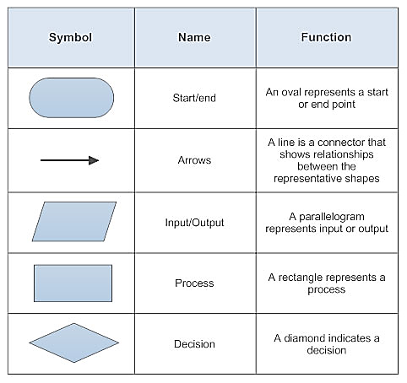

Action

Input/Output

Process

Start

Decision

Decision

End

Input/Output

Action

Action

Yes

**Level 4**

Action

Yes

Push Red Button

Action

Yes



Push Yellow Button

Push Red Button

No

Action

Action

No

Action

No



**Step 2:**

Push the **green** Button to play pass it on and press **red** to play solo.

**Step 3:**

Follow the pattern until you lose focus of the pattern.

**Step 1: START**

Push any Button to turn on the game

**END**